**The route**

|  |  |
| --- | --- |
| **Distance (Kms)** | **Place** |
| 0 Kms - Start Point | CITI Bank Office at M.G.Road (Landmark: Prestige Meridian Tower) |
| 150 Kms | U-Turn at Midway to Chamundi Hills – (Landmark: Green billboard that say MAK Lubricants) |
| 300 Kms - End Pint | CITI Bank Office at M.G.Road (Landmark: Prestige Meridian Tower) |

**[Time Station 1**](Manned) **-** Café Coffee Day, M.G.Road **- Open: 0530Hrs | Close: 0630Hrs**

**[Time Station 2]**(Unmanned) **-** Mc Donald & Kamat hotel **- Open: 0737Hrs | Close: 1018Hrs**

**[Time Station 3]**(Manned)  **-** Midway on the Chamundi Hill **- Open: 0955Hrs | Close: 1530Hrs**

**[Time Station 4]**(Unmanned)  **-** Maddur Café Coffee Day **- Open: 1200Hrs | Close: 2010Hrs**

**[Time Station 5]**(Manned) **-** Café Coffee Day , M.G.Road **- Open: 1420Hrs | Close: 0130Hrs Sunday 13th Feb**

**Detailed Route**

**[Time Station 1] Open: 0530Hrs and Close: 0630Hrs**

**0 Kms** – Café Coffee Day inside the Prestige Meridian tower

*(Assemble by 0430Hrs, get the liability form and Brevet cards stamped, get the checklist of safety measures checked, pay INR 350 for registration, get your brevet cards stamped and start. Time station opens at 0530Hrs and ends at 0630Hrs)*

**Note:** THERE IS NO PARKING AT THE PRESTIGE MERIDIAN BUILDING, PARK YOUR VEHICLES EITHER AT CUBBON PARK OR ANY PARKING SPOT ON MG ROAD AND COME WITH YOUR CYCLES TO THE VENUE.

**1.4 Kms -** From MG Road, CITI Bank, towards Cubbon Park, take 2nd left at the Junction intoKasturba

Road**.**

**2.18 Kms -** Take the 2nd left. You will see a Coffee Day square, a ship hull shaped building with left on

both the sides, Take 2nd Left. You will find Vittal Mallya Hospitalon your left. The road is called Vittal Mallya road, you will see Kanteerva stadium on your right.

**2.75 Kms** - Take a right, more of a U turn around Kanteerva Stadium.

*(Next is a divider road, be on your right. Next is a signal, with LIC in front of you, continue*

*straight****.)***

**3.7 Kms** - Signal, United India Assurance building, keep going straight.

**4 Kms**  - At the signal, take right. *(Go straight, there is a flyover at about 300-500 meters, go over it)*

**4.5 Kms -** Ride on the flyover... *(The flyover ends at 7.3kms, continue straight. Next is a*

*stretch of crappy road, construction and traffic makes it worse... be careful guys...)*

**8.85 Kms -** You will find a huge satellite bus stand and Big Bazaar....Again a patch of bad road, the metro

under construction... please don’t hurt yourselves... ride safe...

**12.38 Kms -** The huge Gopalan Enclave on the left hand side of road...too early to grab anything from the

Mc D... continue on the same road...

**12.9 Kms -** On the right hand side is the Bangalore University...

**14.9 Kms -** RV College.

**17.61kms -** Kingeri (*I guess hardly any traffic at this time, I mean while going, coming back will Probably*

*not be such a nice patch after all...)*

**20.20 Kms -** Raja Rajeshwari General Hospital.

**28.9 Kms -** Wonder la billboard

**46.4 Kms -** TheRamnagram Town begins and end at 52.6kms.

**60kms -** TheChennapatna Town**,** the land of toys...

**69.8kms -** Kamat, well you can have breakfast but hold on till the next time station, that comes up next

**[Time Station 2] Open: 0737Hrs and Close: 1018Hrs**

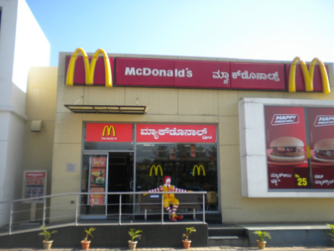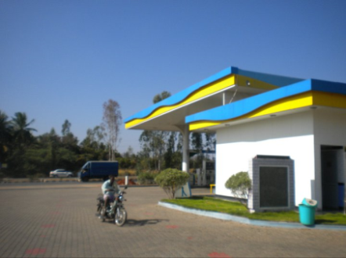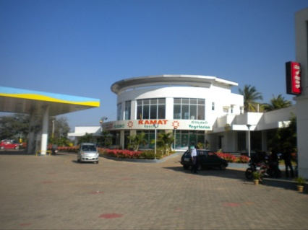

**71.8kms -** Mc Donald & Kamat hotel, Unmanned Time Station – 2

*(Enter the Mc Donald or Kamat, get a receipt, that will bear the time stamp, this will act as*

*a way to check what time you reached this time station. Time station opens at 0737Hrs and closes at 1018Hrs. Please don’t worry if you reach a few minutes late, carry on...)*

**98.8 Kms** - Mandya town entrance and 103.8kms Mandya town Exit, no turning back, go ahead, just

50Kms left before you reach halfway.

**125.7Kms** - Srirangapattana town entrance and 128.9Kms Srirangapattana town Exit

**130 Kms**  - Mysore city limits start signboard.

**136.8 Kms** - Water canal over bridge. Go under it...

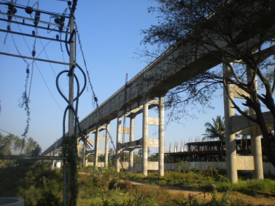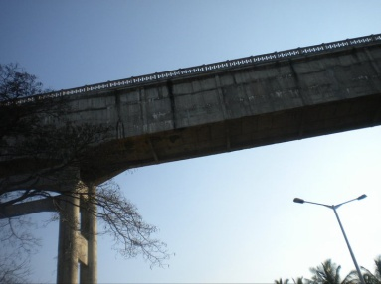

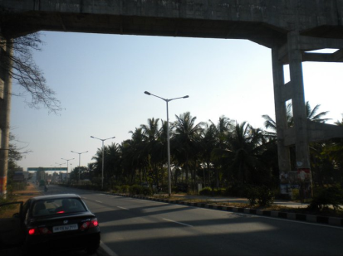

**137.1 Kms** - Bananur Road, take left...

**144.7 Kms -** T junction, Take Right... head towards Chamundi Hills

*(You could follow the yellow signboard, trust me very prominent ones, for the same)*

**[Time Station 3] Open: 0955Hrs and Close: 1530Hrs**

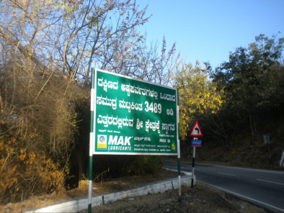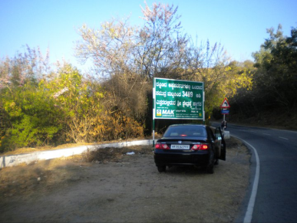**150 Kms** -Turn around point –, at the Green MAK Lub Bill board, its hard to miss. Since it is a Manned station, you will need to get your card stamped by the Volunteer present and then turn back. Time Station opens at 0955Hrs and closes at 1530Hrs.

**[Time Station 4] Open: 1200Hrs and Close: 2010Hrs**

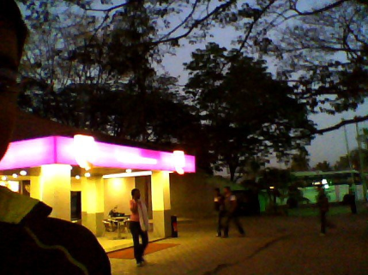

**220 Kms** - After you turn back, the 4th time station, again an unmanned one is at Maddur Café Coffee

Day, this is 70kms from the turnaround point. You have to get a receipt from them that will

have the time you reached there. The station opens at 1200Hrs and closes at 2010Hrs.

**[Time Station 5] Open: 1420Hrs and Close: 0130Hrs Sunday 13th Feb 2011**

Come back the same way to the end of the trip, the 5th and the last time station also at the end point, the Café Coffee Day inside the Prestige Meridian Towers, the CITI Bank building. In case you are interested in getting the medal, pay the medal fees of INR 350 and submit your Brevet card, after getting it stamped and signing it. The last time station opens at1420 and closes at 0130Hrs on Sunday 13th Feb.

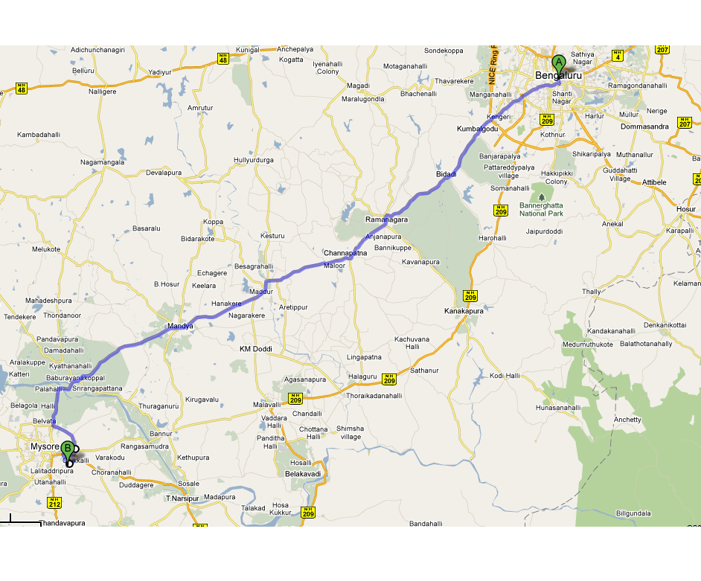**Route Sketch**